GIS APP
Table of Contents
Monorepo Architecture Setup 2
Project Setup & Implementation 2
Tests 3
Unit Tests 3
Integration Tests 3
E2E Tests 3
Performance Tests 3
Accessibility Tests 3
Monorepo Structure 4
Appendix 1 – Cli commands 6
Appendix 2 - GIS Application Toolbar Test Plan 10

Monorepo Architecture Setup
- Monorepo Initialization
  - Set up Nx / Angular workspace with multiple projects
  - Configure TypeScript paths and base configurations
  - Set up shared ESLint and Prettier configurations
- Project Structure Creation
  - Create main GIS application project
  - Set up shared UI library project
  - Create shared data/models library
  - Set up shared services library
  - Create shared utilities library
- Build, Tests & Development Configuration
  - Configure build scripts for individual projects
  - Set up affected builds and tests
  - Configure development servers and proxies
  - Set up environment configurations for each project
  - Configure CI/CD for monorepo

Project Setup & Implementation
- GIS App Initialization
  - Create main GIS application within monorepo
  - Configure app-specific routing
  - Set up app-specific environments
  - Configure build outputs and assets
- Shared Libraries Setup
  - Common UI components library
  - Map-related shared functionality
  - Shared data models
  - Shared services
    - HTTP
    - authentication
    - logging
- Layout & Core Components
  - Shared UI Components Library
  - GIS App Layout Implementation
  - Map Integration in Shared Library
- Toolbar Functionality
  - Toolbar Components in UI Library
  - App-Specific Toolbar Implementation
  - GIS & Trip Features and shared utilities

Tests
Unit Tests - Testing each toolbar component in isolation:
- Right toolbar mode selection and button states
- Top toolbar dynamic content updates
- Left toolbar show/hide functionality
- Toolbar service state management
Integration Tests - Testing toolbar interactions:
- Communication between all three toolbars
- State synchronization across components
- Map integration with toolbar actions
E2E Tests - Testing complete user workflows:
- User navigation flows
- Complex multi-step interactions
- Responsive behaviour across devices
Performance Tests - Ensuring smooth operation:
- Rendering performance benchmarks
- Memory leak prevention
- Animation performance
Accessibility Tests - Ensuring usability for all:
- Keyboard navigation
- Focus management

Monorepo Structure
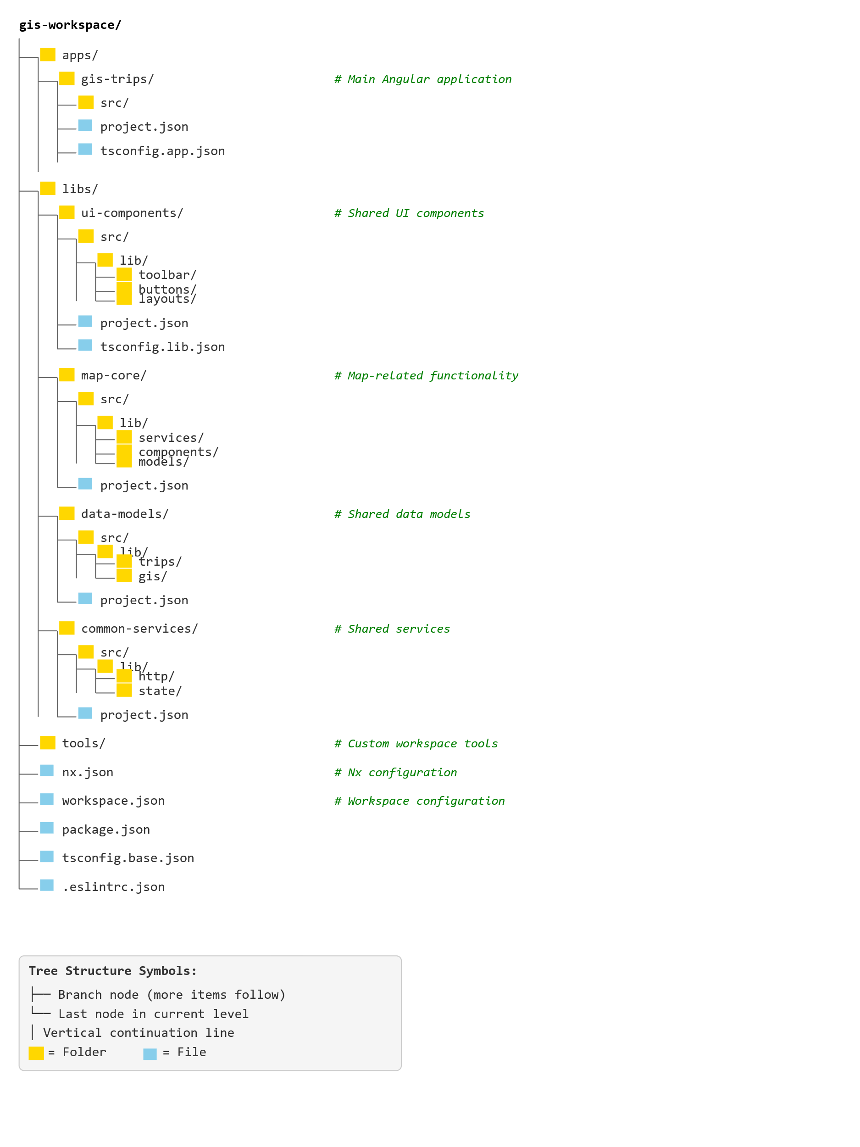

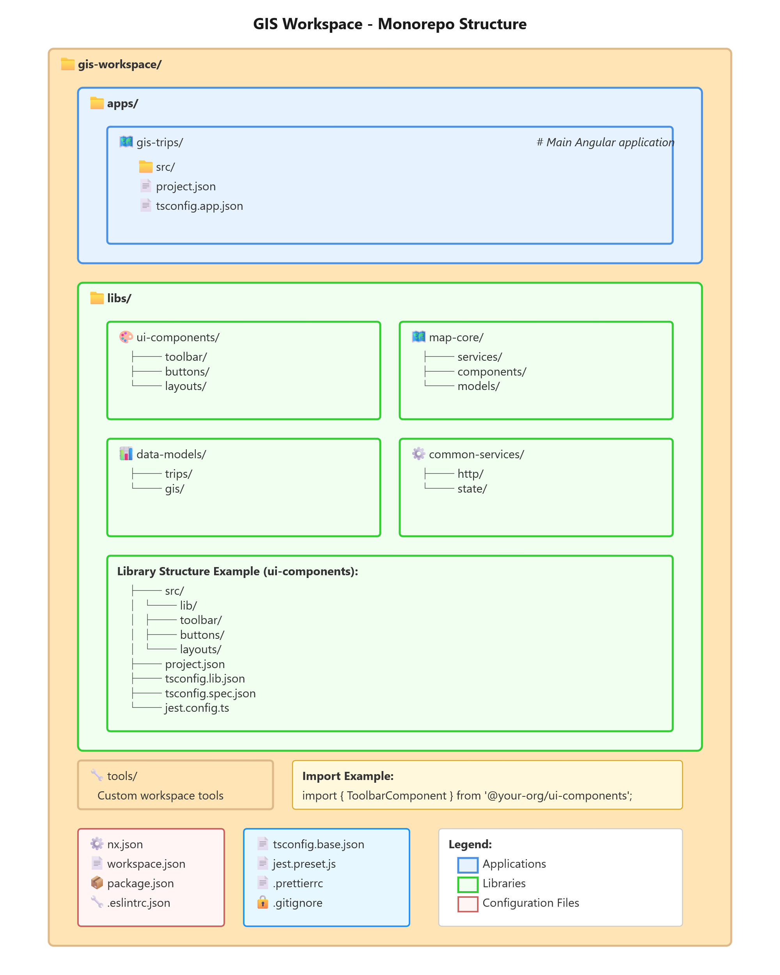

Appendix 1 – Cli commands
# 1. Create new Nx workspace
npx create-nx-workspace@latest maps-workspace --preset=angular-monorepo --appName=maps-app --style=css --routing=true --packageManager=npm

# Alternative: Create empty workspace and add Angular later
# npx create-nx-workspace@latest maps-workspace --preset=apps --packageManager=npm
# cd maps-workspace
# nx g @nx/angular:application maps-app --routing=true --style=css

cd maps-workspace

# 2. Install required dependencies for the workspace
npm install @angular/google-maps primeng primeicons

# 3. Generate Angular application (if not created during workspace setup)
# nx g @nx/angular:application maps-app --routing=true --style=css --directory=apps

# 4. Generate shared libraries (recommended for monorepo)
nx g @nx/angular:library shared-ui --directory=libs --buildable=true
nx g @nx/angular:library map-core --directory=libs --buildable=true
nx g @nx/angular:library shared-data --directory=libs --buildable=true

# 5. Generate components in the main application
nx g @nx/angular:component components/map --project=maps-app
nx g @nx/angular:component components/top-bar --project=maps-app
nx g @nx/angular:component components/left-bar --project=maps-app
nx g @nx/angular:component components/right-bar --project=maps-app

# 6. Generate shared components in libraries
nx g @nx/angular:component map --project=shared-ui --export=true
nx g @nx/angular:component panel --project=shared-ui --export=true
nx g @nx/angular:component card --project=shared-ui --export=true

# 7. Generate services in shared libraries
nx g @nx/angular:service services/map --project=map-core
nx g @nx/angular:service services/location --project=map-core
nx g @nx/angular:service services/geocoding --project=map-core

# 8. Generate data access services
nx g @nx/angular:service data-access/map-data --project=shared-data
nx g @nx/angular:service data-access/location-data --project=shared-data

# 9. Generate interfaces and models
nx g @nx/angular:interface models/location --project=shared-data
nx g @nx/angular:interface models/map-options --project=shared-data
nx g @nx/angular:interface models/marker --project=shared-data

# 10. Generate additional applications for different environments
nx g @nx/angular:application maps-admin --routing=true --style=css --directory=apps
nx g @nx/angular:application maps-mobile --routing=true --style=css --directory=apps

# 11. Generate E2E tests
nx g @nx/cypress:e2e maps-app-e2e --project=maps-app

# 12. Build commands
# Build specific application
nx build maps-app

# Build all applications
nx run-many --target=build --all

# Build with production configuration
nx build maps-app --configuration=production

# 13. Serve commands
# Serve specific application
nx serve maps-app

# Serve with specific port
nx serve maps-app --port=4200

# 14. Test commands
# Test specific project
nx test maps-app

# Test specific library
nx test shared-ui

# Test all projects
nx run-many --target=test --all

# 15. Lint commands
# Lint specific project
nx lint maps-app

# Lint all projects
nx run-many --target=lint --all

# 16. Generate additional useful items
# Generate guards
nx g @nx/angular:guard guards/map --project=maps-app

# Generate pipes
nx g @nx/angular:pipe pipes/coordinate-format --project=shared-ui --export=true
nx g @nx/angular:pipe pipes/distance-format --project=shared-ui --export=true

# Generate interceptors
nx g @nx/angular:interceptor interceptors/api --project=shared-data

# Generate resolvers
nx g @nx/angular:resolver resolvers/map-data --project=maps-app

# 17. Generate feature libraries (recommended approach)
nx g @nx/angular:library feature-map --directory=libs --routing=true
nx g @nx/angular:library feature-navigation --directory=libs --routing=true
nx g @nx/angular:library feature-search --directory=libs --routing=true

# Generate components in feature libraries
nx g @nx/angular:component map --project=feature-map --export=true
nx g @nx/angular:component navigation --project=feature-navigation --export=true
nx g @nx/angular:component search --project=feature-search --export=true

# 18. Workspace maintenance commands
# Check dependency graph
nx graph

# Show affected projects (useful for CI/CD)
nx affected:build
nx affected:test
nx affected:lint

# Update Nx workspace
nx migrate latest

# Check workspace health
nx workspace-lint

# 19. Library-specific commands
# Build libraries
nx build shared-ui
nx build map-core
nx build shared-data

# Publish libraries (if needed)
nx build shared-ui --prod
nx publish shared-ui

# 20. Docker commands (if needed)
# Generate Dockerfile
nx g @nx/node:dockerfile maps-app

Appendix 2 - GIS Application Toolbar Test Plan
Overview
This test plan covers all aspects of the three-toolbar system:
- Top toolbar (static, content changes based on right toolbar selection)
- Right toolbar (always visible, contains mode selection buttons)
- Left toolbar (collapsible, shows when triggered by right toolbar button)
Test Structure
1. Unit Tests
1.1 Right Toolbar Component Tests
Test Suite: RightToolbarComponent
typescript
describe('RightToolbarComponent', () => {
// Component Initialization
- should create component successfully
- should render all mode buttons correctly
- should have no button selected by default
- should display correct icons for each mode button
- should display correct tooltips on hover

// Button Selection
- should highlight selected button with active state
- should remove active state from previously selected button
- should emit modeChanged event when button is clicked
- should include mode details in emitted event
- should not emit event when clicking already selected button
- should update aria-pressed attribute for accessibility

// Button State Management
- should disable buttons based on input configuration
- should show/hide buttons based on user permissions
- should update button states when permissions change
- should maintain selection when non-selected button is disabled

// Keyboard Navigation
- should navigate through buttons with arrow keys
- should select button with Enter key
- should select button with Space key
- should wrap focus from last to first button
- should skip disabled buttons during navigation
});
1.2 Top Toolbar Component Tests
Test Suite: TopToolbarComponent
typescript
describe('TopToolbarComponent', () => {
// Component Initialization
- should create component successfully
- should display default buttons when no mode is selected
- should have empty toolbar if no default configuration

// Dynamic Content Loading
- should update buttons when mode changes
- should clear previous buttons before loading new ones
- should handle empty button configuration gracefully
- should preserve button order from configuration
- should apply correct styling to buttons

// Button Functionality
- should emit correct action when button is clicked
- should disable buttons based on context
- should show loading state for async actions
- should display button badges/counters correctly
- should show dropdown menus for grouped actions

// Responsive Behavior
- should collapse buttons into menu on small screens
- should show priority buttons when space is limited
- should maintain functionality in collapsed state
});
1.3 Left Toolbar Component Tests
Test Suite: LeftToolbarComponent
typescript
describe('LeftToolbarComponent', () => {
// Component Initialization
- should create component successfully
- should be hidden by default
- should have correct initial width
- should load with closed state

// Show/Hide Functionality
- should show when trigger event is received
- should hide when close button is clicked
- should hide when clicking outside (if configured)
- should hide when ESC key is pressed
- should maintain content state when hidden
- should animate slide-in transition
- should animate slide-out transition

// Content Loading
- should load content based on selected mode
- should display loading spinner while content loads
- should handle content loading errors gracefully
- should cache previously loaded content (if enabled)
- should destroy content on hide (if configured)

// Content Interaction
- should emit events from child components
- should validate form inputs before submission
- should show validation errors appropriately
- should reset forms when switching modes
- should preserve form state when specified

// Responsive Behavior
- should adjust width on mobile devices
- should overlay map on small screens
- should be swipeable on touch devices
});
1.4 Toolbar Service Tests
Test Suite: ToolbarService
typescript
describe('ToolbarService', () => {
// State Management
- should initialize with default state
- should update current mode when selection changes
- should broadcast mode changes to subscribers
- should maintain mode history
- should provide current mode observable

// Configuration Management
- should load toolbar configurations
- should return buttons for specific mode
- should handle missing configurations gracefully
- should merge default and custom configurations
- should validate configuration schema

// Communication
- should facilitate communication between toolbars
- should queue events when no subscribers
- should handle multiple subscribers correctly
- should cleanup subscriptions on destroy

// Left Toolbar Control
- should track left toolbar visibility state
- should emit show/hide events
- should prevent multiple show events
- should synchronize state across components
});
2. Integration Tests
2.1 Toolbar Interaction Tests
Test Suite: Toolbar Integration
typescript
describe('Toolbar Integration', () => {
// Right-Top Toolbar Integration
- should update top toolbar when right toolbar button is clicked
- should load correct button set for each mode
- should maintain button state synchronization
- should handle rapid mode switches correctly
- should preserve top toolbar state when switching back to mode

// Right-Left Toolbar Integration
- should show left toolbar when specific right button is clicked
- should load correct content in left toolbar for mode
- should hide left toolbar when different mode is selected
- should maintain left toolbar content during mode retention
- should handle show/hide animations without conflicts

// Three-Way Integration
- should coordinate all three toolbars correctly
- should handle mode change affecting all toolbars
- should maintain consistent state across all toolbars
- should handle concurrent actions appropriately
- should recover from error states gracefully

// Map Integration
- should update map when toolbar actions are triggered
- should reflect map state in toolbar buttons
- should disable relevant buttons during map operations
- should synchronize selection tools with map interaction
});
2.2 State Synchronization Tests
Test Suite: State Synchronization
typescript
describe('State Synchronization', () => {
// Cross-Component State
- should synchronize selected mode across all toolbars
- should update button states based on global state
- should handle state conflicts appropriately
- should maintain state during route changes
- should restore state after page refresh

// Async State Updates
- should handle async button configuration loading
- should manage loading states across toolbars
- should handle partial state updates
- should rollback state on update failure
});
3. End-to-End (E2E) Tests
3.1 User Flow Tests
Test Suite: Toolbar User Flows
cypress
describe('Toolbar User Flows', () => {
// Basic Navigation Flow
- user should see all three toolbars on page load
- user should click right toolbar button and see top toolbar update
- user should click different mode and see content change
- user should open left toolbar and interact with content
- user should close left toolbar and maintain mode selection

// Complex Interaction Flow
- user should select drawing mode and see drawing tools
- user should open left toolbar to configure drawing options
- user should draw on map with selected configuration
- user should switch modes and return to see preserved drawing
- user should complete multi-step workflow across toolbars

// Error Recovery Flow
- user should see error message when action fails
- user should retry failed action successfully
- user should continue workflow after error recovery
- user should not lose data during error states
});
3.2 Responsive Tests
Test Suite: Responsive Toolbar Behavior
cypress
describe('Responsive Toolbar Tests', () => {
// Desktop to Mobile
- should adapt toolbars when resizing from desktop to mobile
- should collapse top toolbar buttons into menu
- should make left toolbar full-width on mobile
- should maintain functionality on all screen sizes

// Touch Interactions
- should respond to touch events on mobile devices
- should support swipe gestures for left toolbar
- should have appropriate touch targets
- should prevent accidental touches
});
4. Performance Tests
4.1 Rendering Performance
Test Suite: Toolbar Performance
typescript
describe('Toolbar Performance', () => {
// Initial Render
- should render all toolbars within 100ms
- should not block main thread during render
- should lazy load non-critical resources

// Dynamic Updates
- should update toolbar content within 50ms
- should batch multiple updates efficiently
- should use change detection optimization
- should minimize reflows during animations

// Memory Management
- should cleanup event listeners on destroy
- should release component references
- should not leak memory during mode switches
- should manage DOM elements efficiently
});

